Project Design Phase-I Problem Solution Fit

|  |  |
| --- | --- |
| Date | 16 OCTOBER 2022 |
| Team ID | PNT2022TMID16911 |
| Project Name | Industry-Specific Intelligent Fire Management System |

# The customer should just click the alert message to enhance the further step to stop the fire.

Proper network connection and available devices are needed.

The customer used to call for the emergency number 101 to call the fire service team to stop the fire at that time of reporting many products in the industry gets damaged and many lives were death. Now with the use of our product the industry can sense the fire explosion and stop at the initial stage itself. So, it is quite much more easy.

* We are solving the problem of fire spread by automatically detecting the fire at the ignition stage andstop the fire spread easily using Artificial Intelligence and IOT based ideations.

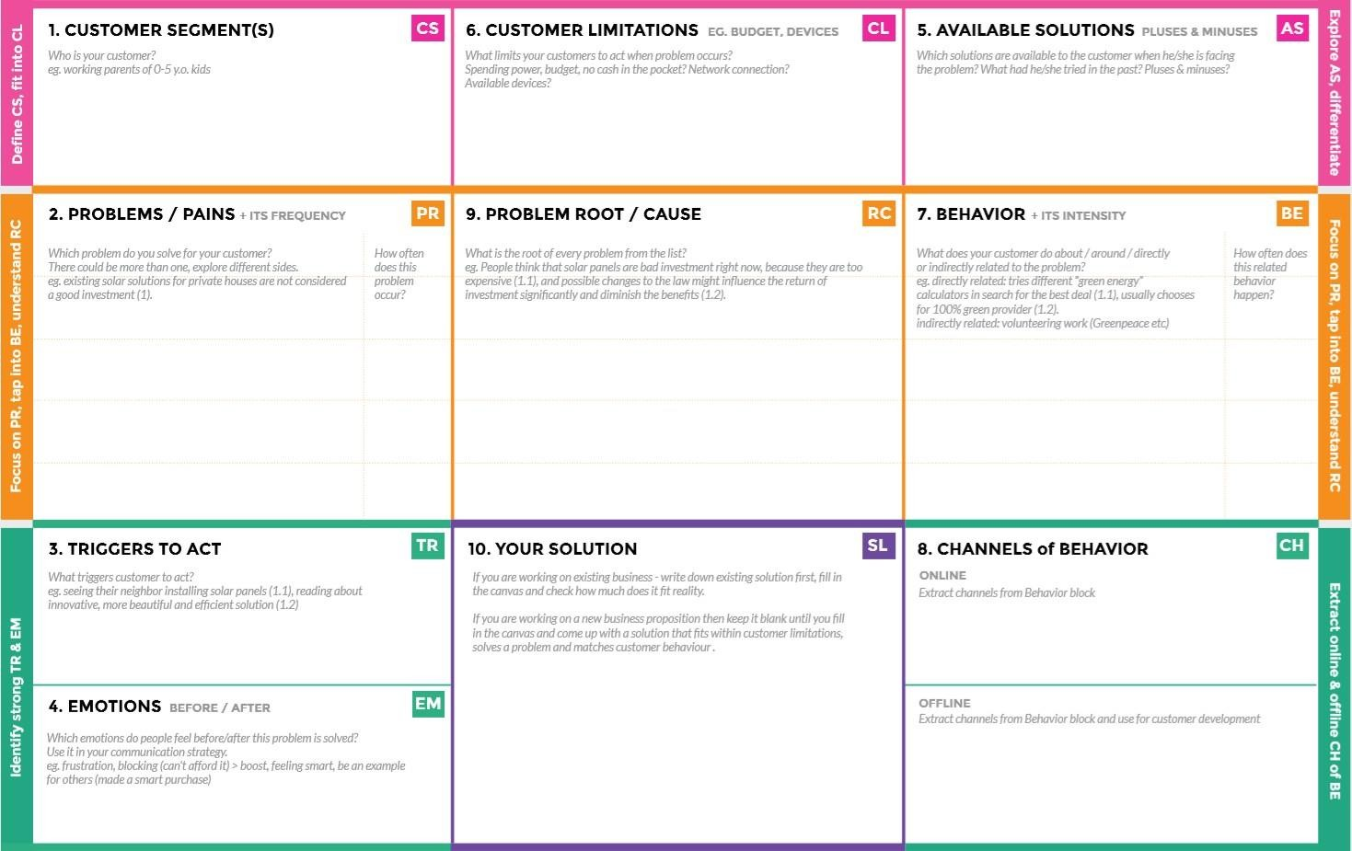

**Before:** Customer is not finding a proper rid for the fire spread problem.

**After:** Now with the help of our product the customer can easily enhance the problem.

The sensors with the help of intelligence can stop the fire spread at the initial stage itself.

Notifications send can be accessed.

We can just access the message from the IOT devices combined with sensors to stop the fire spread at the ignition stage itself. It is much easier, safe to handle.

We can ask our customer to get an experience about our product. We can insist they must need of our product.

* The fire causes a lot of damages in the industry. Usually when it gets fired in an industry the fire service team is called to stop the fire. But now our solution use can stop the fire without the help of fire service.

Industry members as well as others

# At once the message is send to the customers mobile from the sensors- controlled Intelligence the customer himself can give the access to stop the fire spread on the whole.